LETSGo

A complete travel guide

**NAME**-RISHITA RANA

**ROLLNO**-2110991982

**SEMESTER**-5TH

**GROUP**-G5

**INSTRUCTOR**-Lavish Arora

1.HOMEPAGE

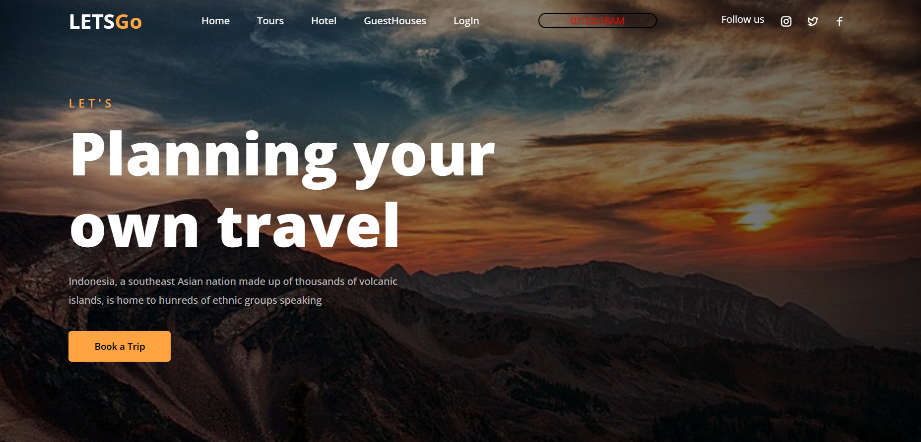

I tried to make this website by deviding it into header,sections and footer.

On the very first page we have navbar on the top and it follows up with all the other pages.

I have added html,css ,javascript in this page.

It is the Homepage of my website.

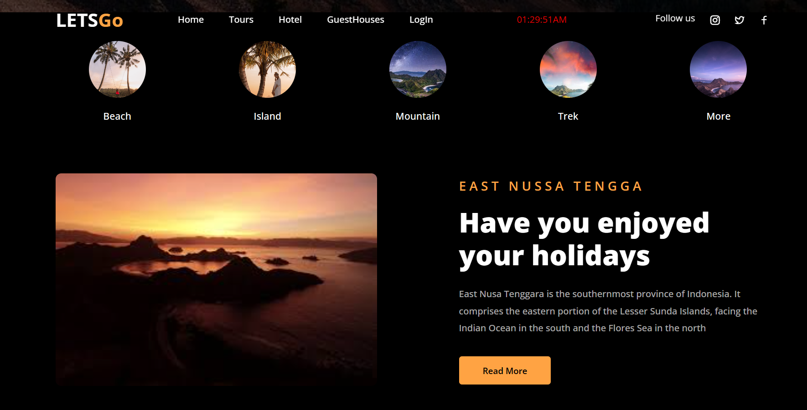

2. Tours

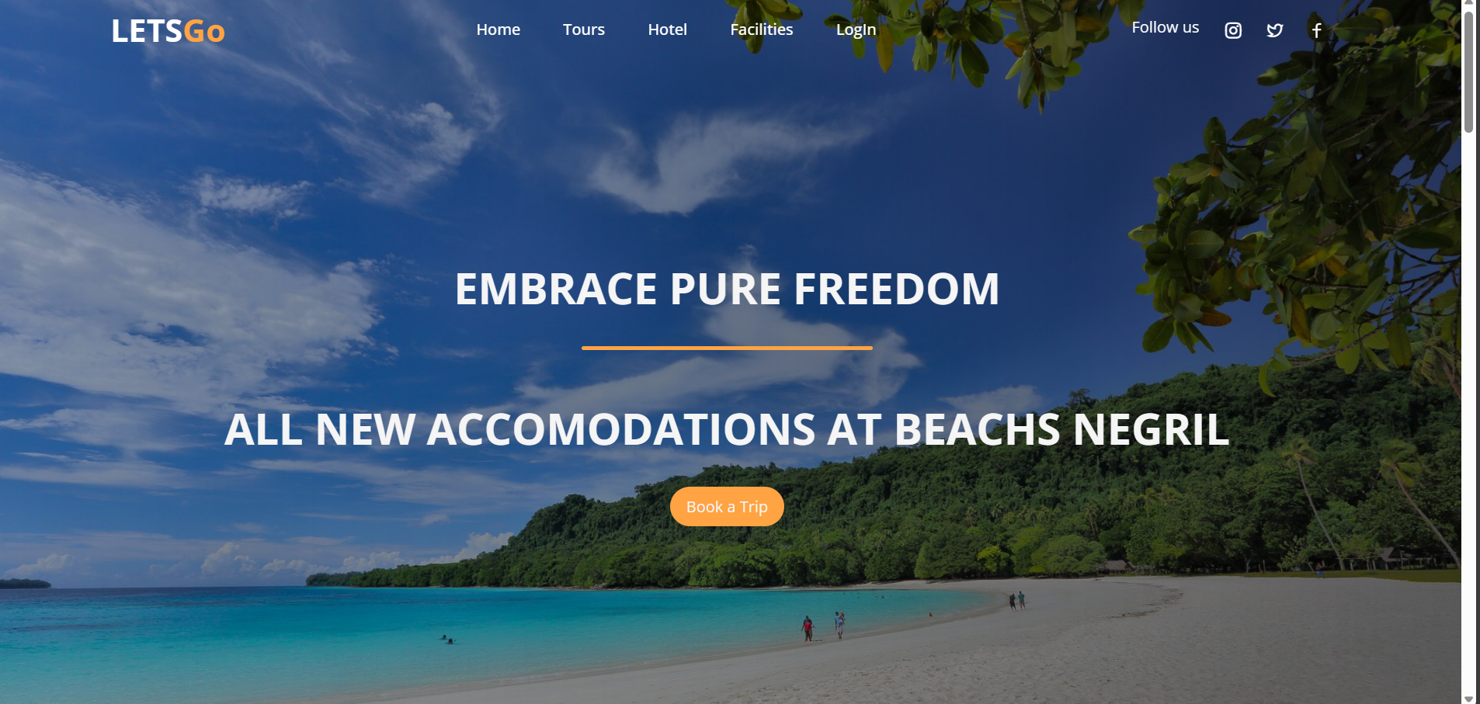

Next we have beaches I have styled it via using css background cover property to set this beautiful page.

WE have used flex in the navbar to display the list tags and the anchor tags.

We have enhanced the brightness to zoom into them.

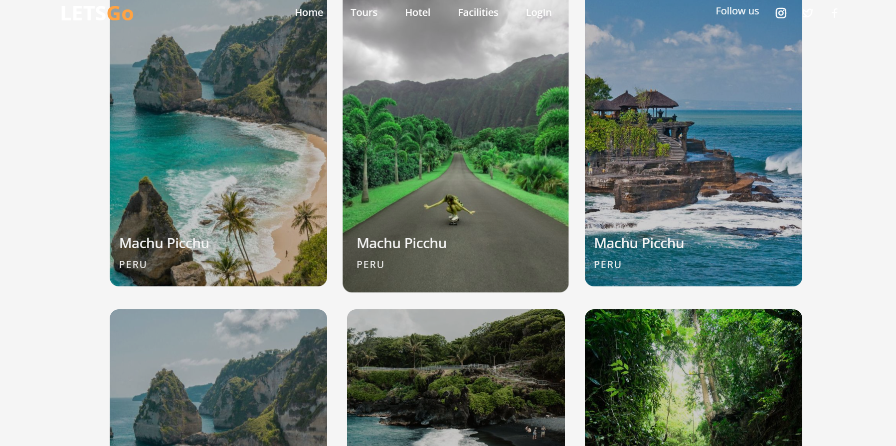

3.HOTELS

4.GUESTHOUSE

5.FACILITY

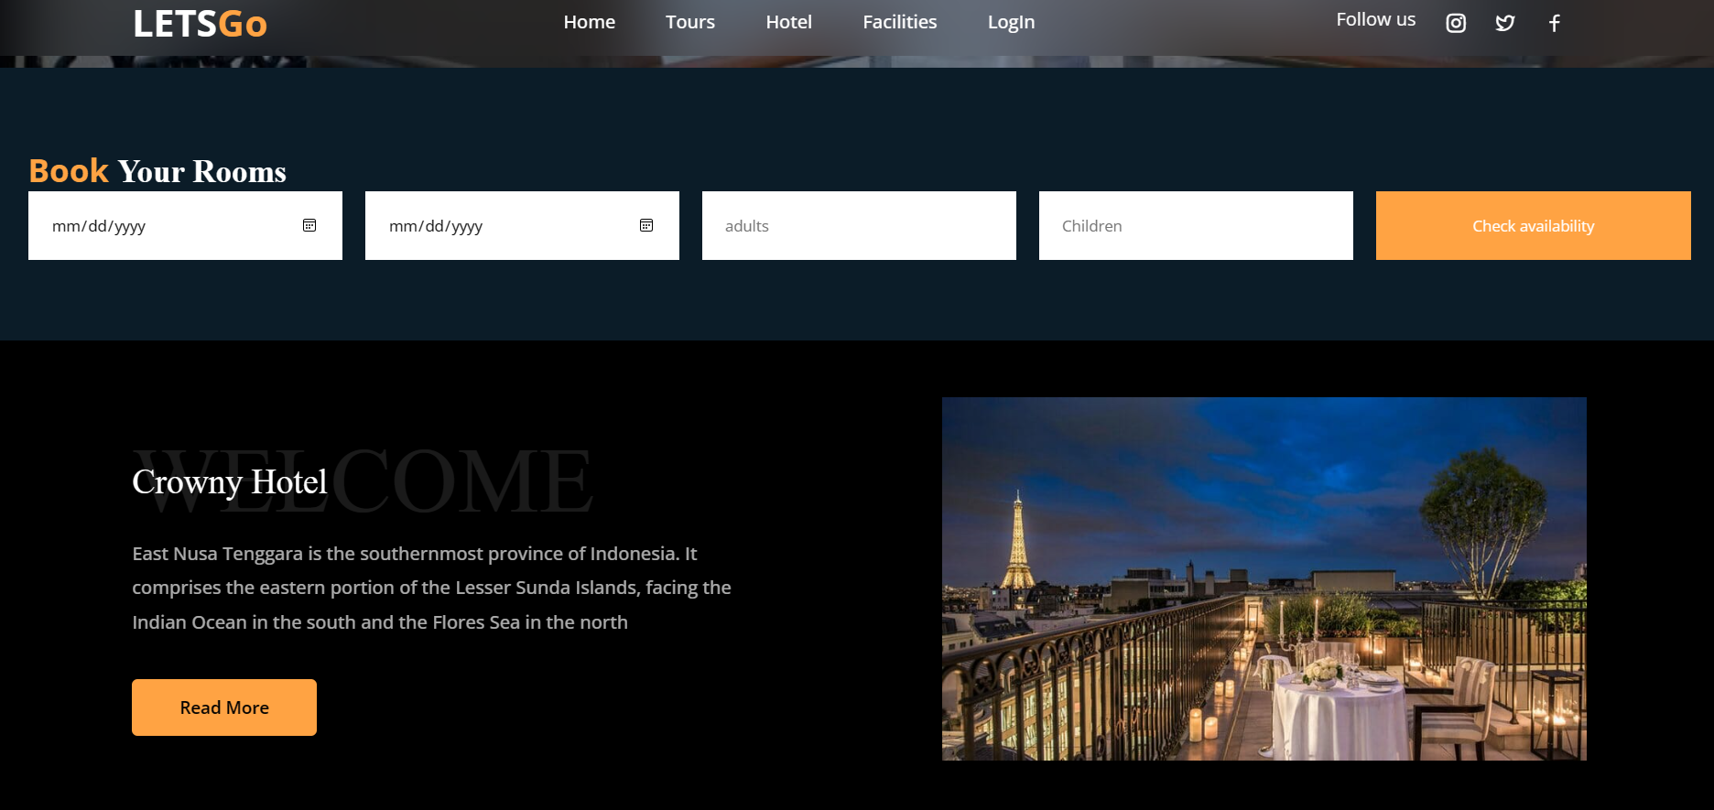

In this we have used form and div display flex like properties to arrange the page also the navbar is fixed.

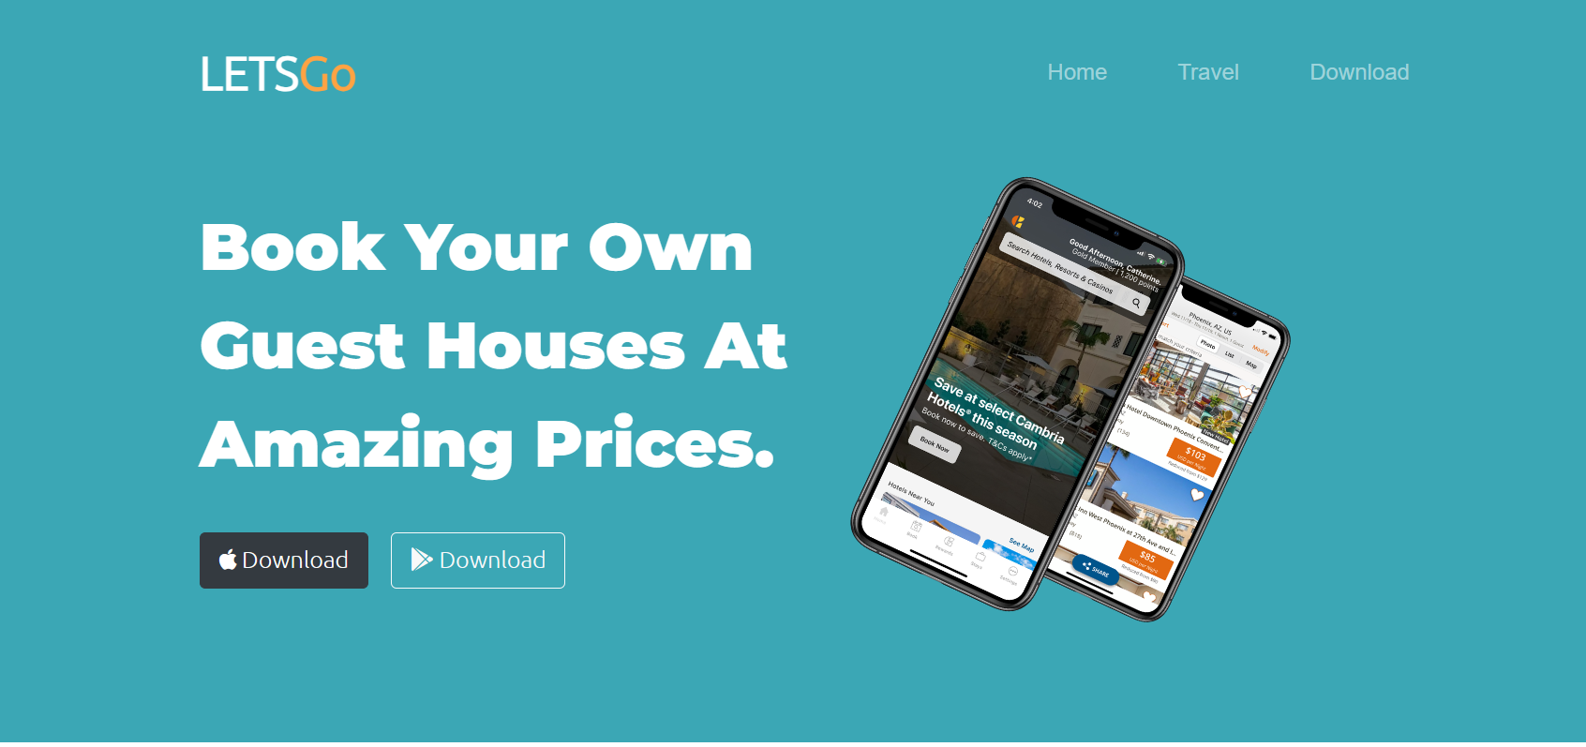

In this we have used bootsrap to built a carousel and rest html and css is used to design and make it.

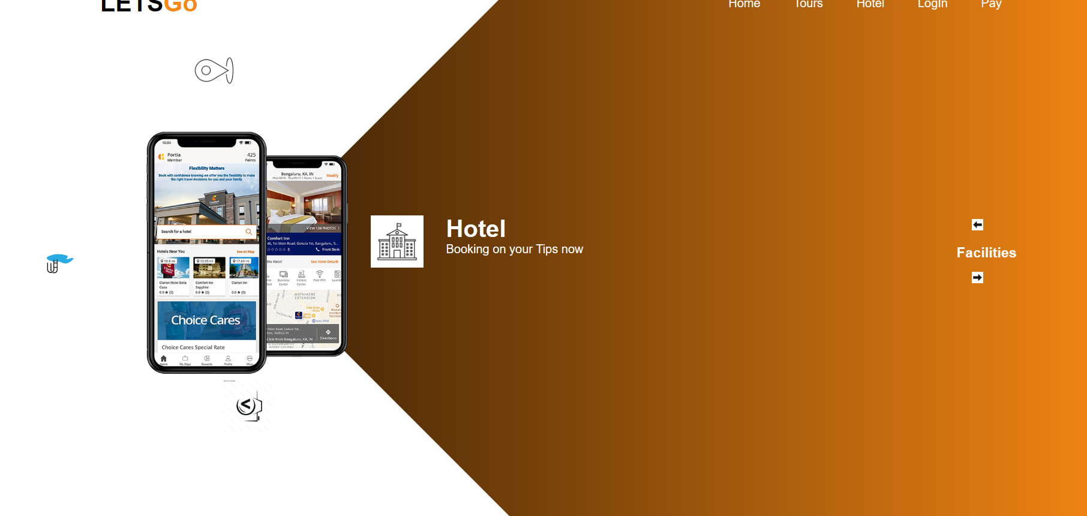

In this a beautiful clockwise rotation is build via using Javascript .

6.LOGIN

7.SignIN

8.Calculator

9.Payement

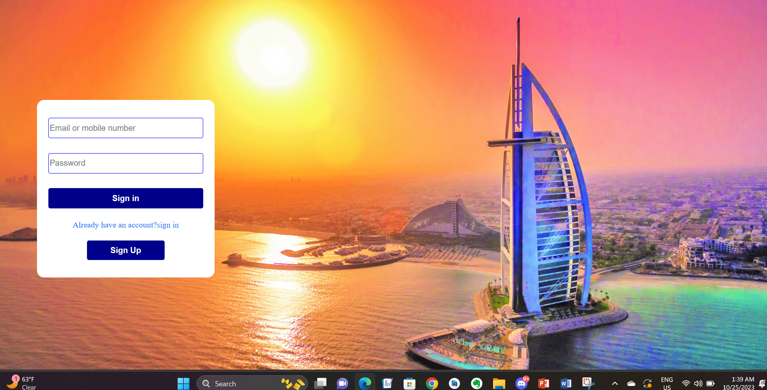

In this we have simply used form,button and background cover property

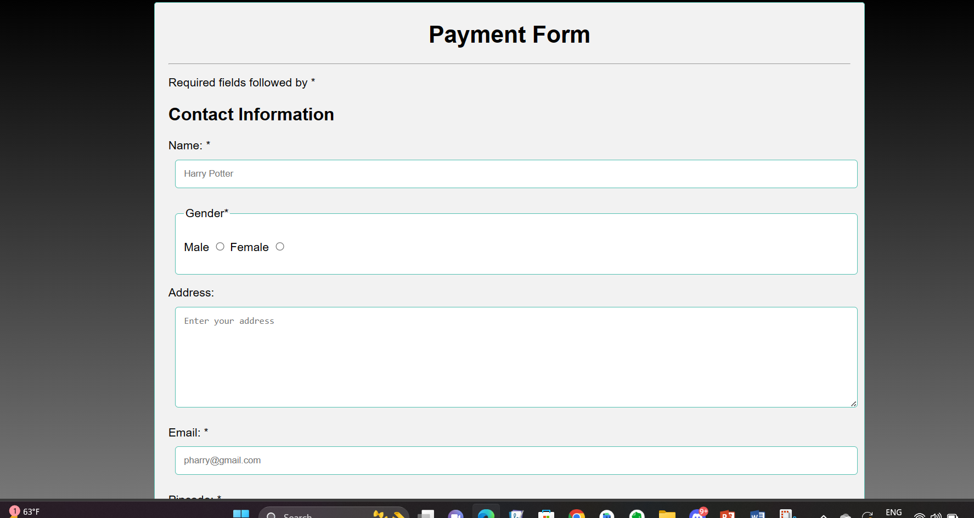

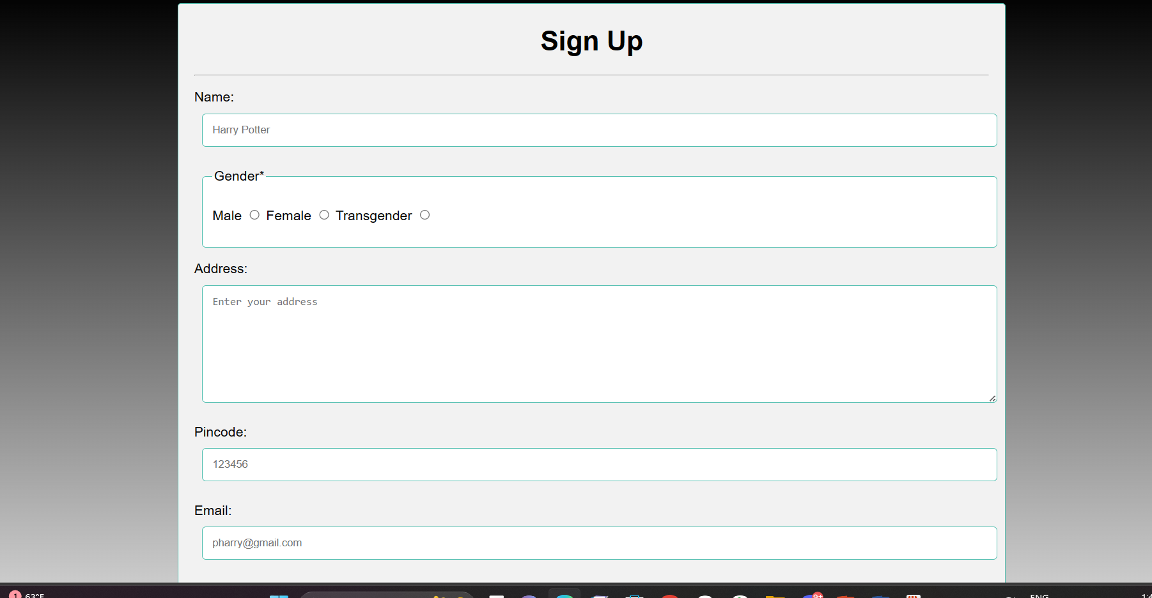

Simple form property is used in these input type and placeholder and table is also used to frame it nicely

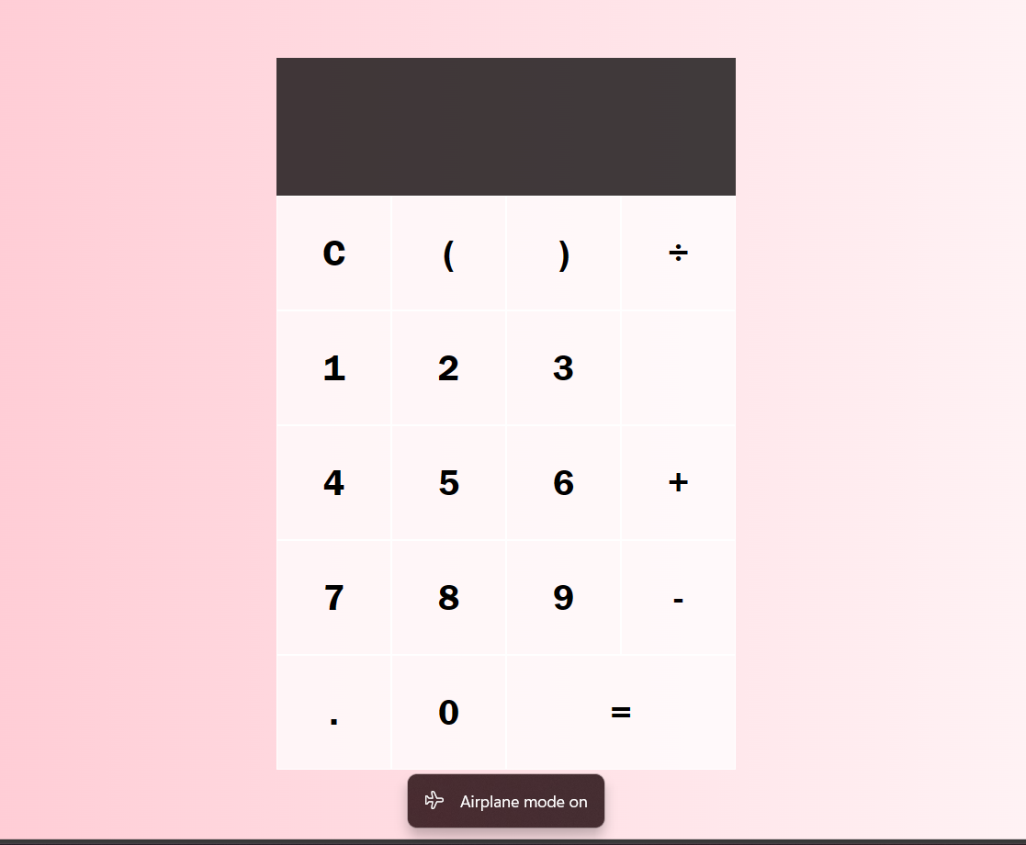

It is made completely with help of javascript.

10.Travel

11. food

12.places

13.nearby

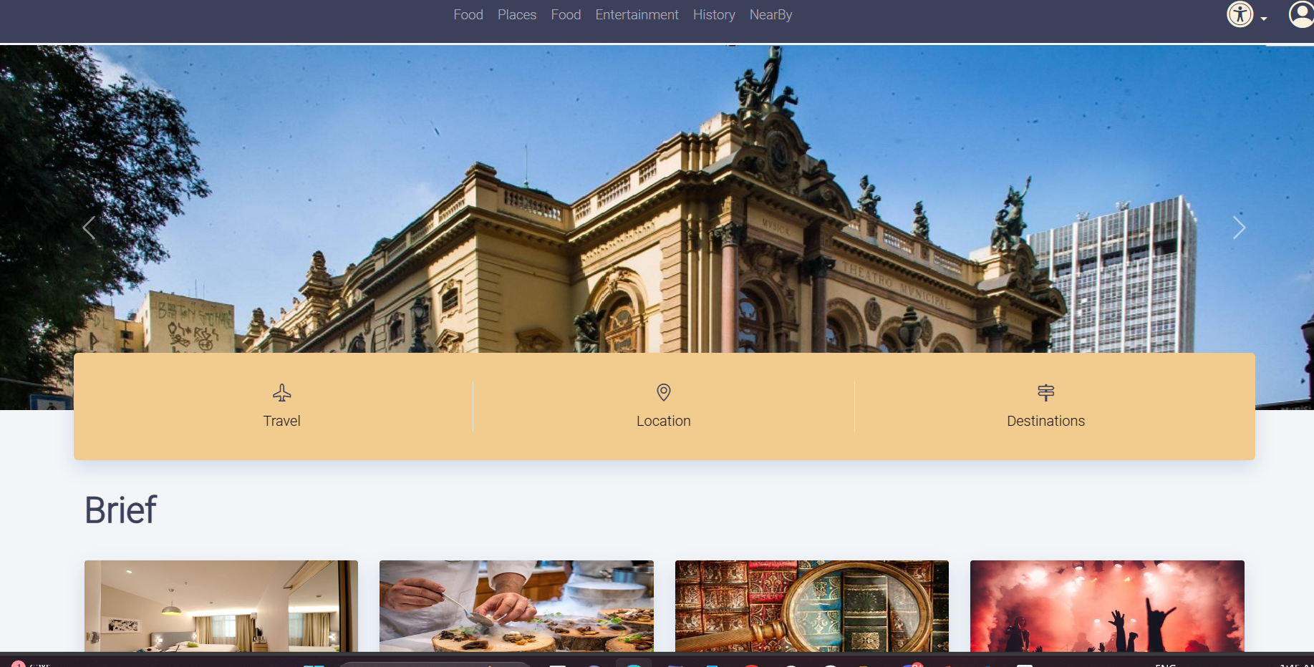

IN THIS BOOTSTRAP IS USED TO COVER ALL THE ELEMENTS AND ALSO DIV TAGS AND FLEX LIKE PROPERTIES ARE USED.

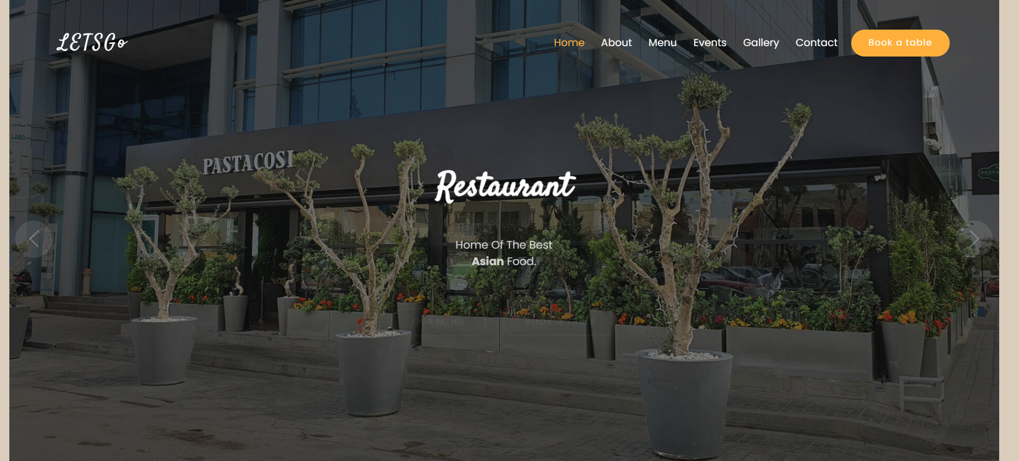

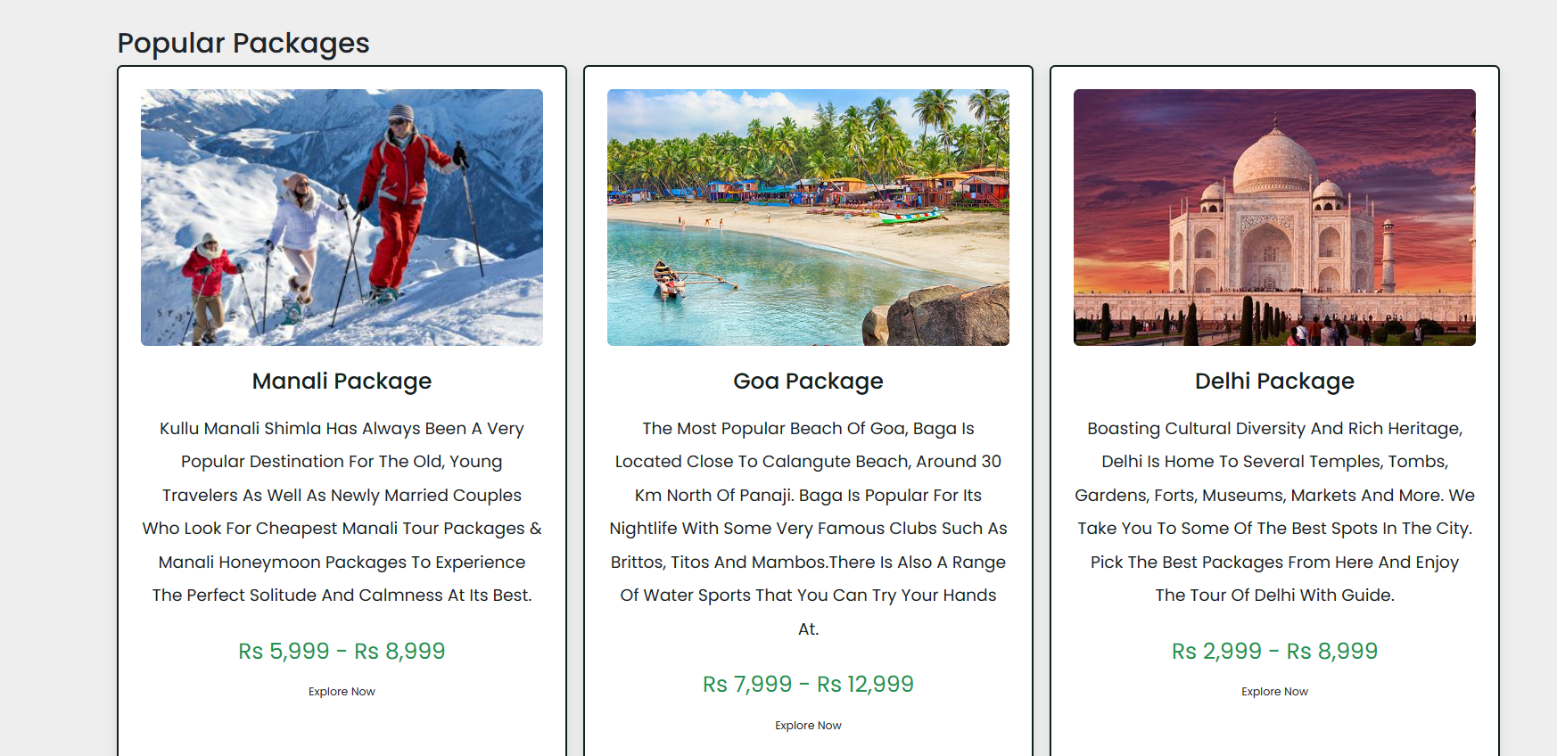

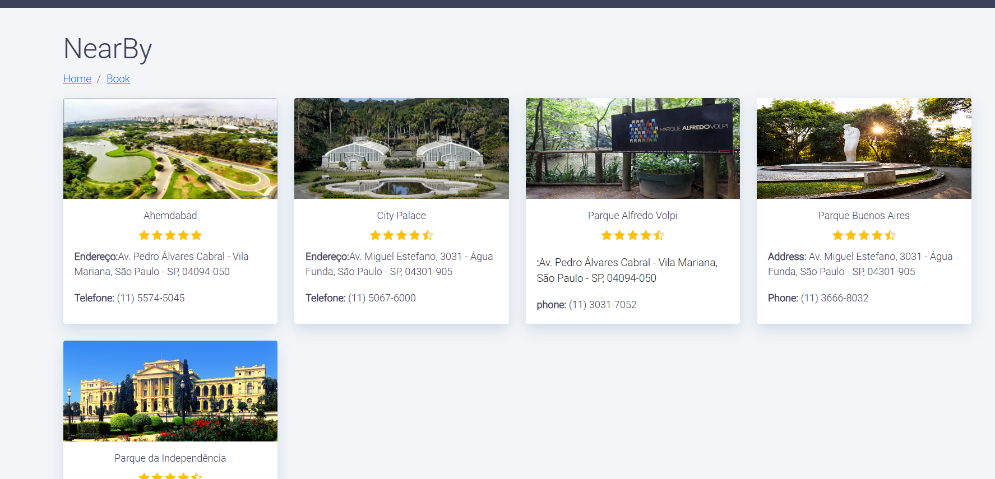

14.Package

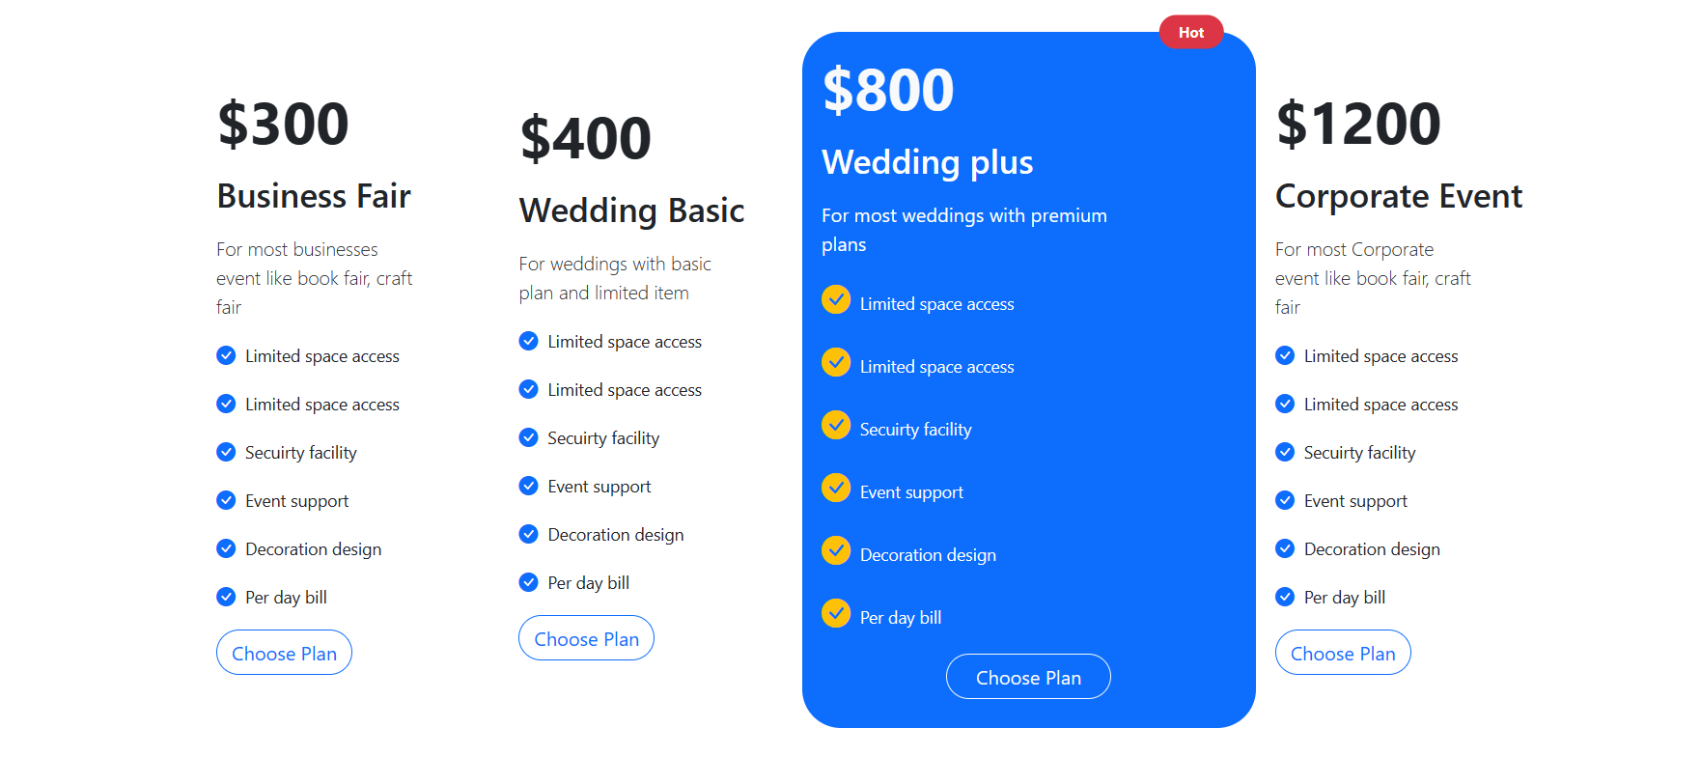

15.review

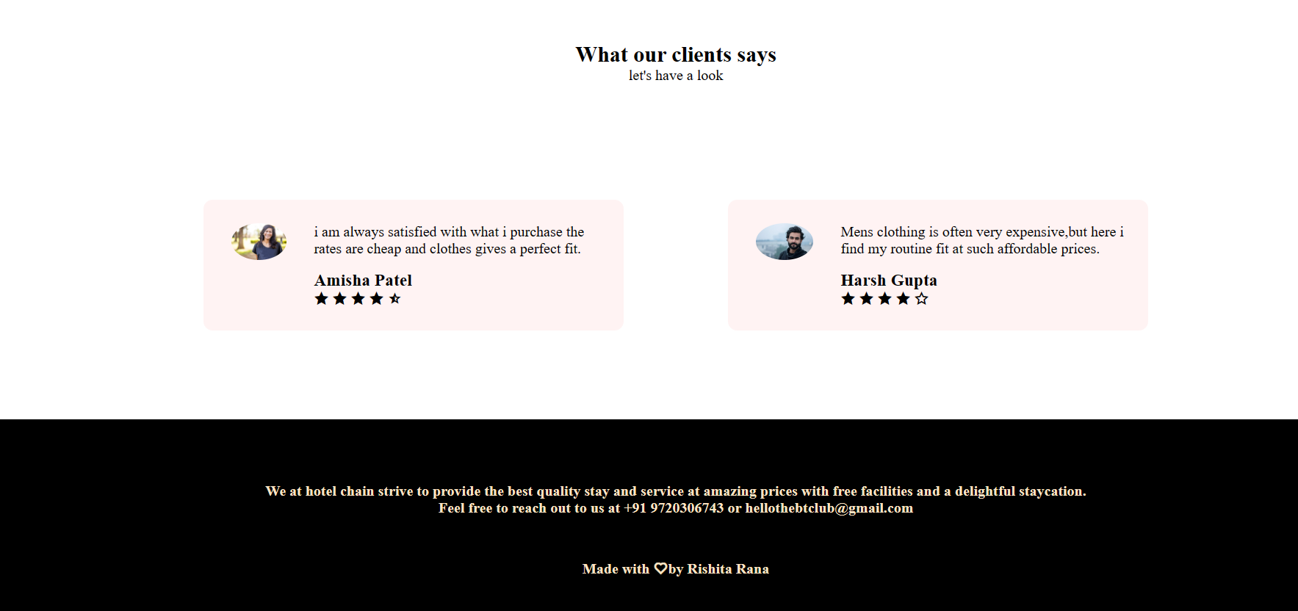

16.SiteSeeing

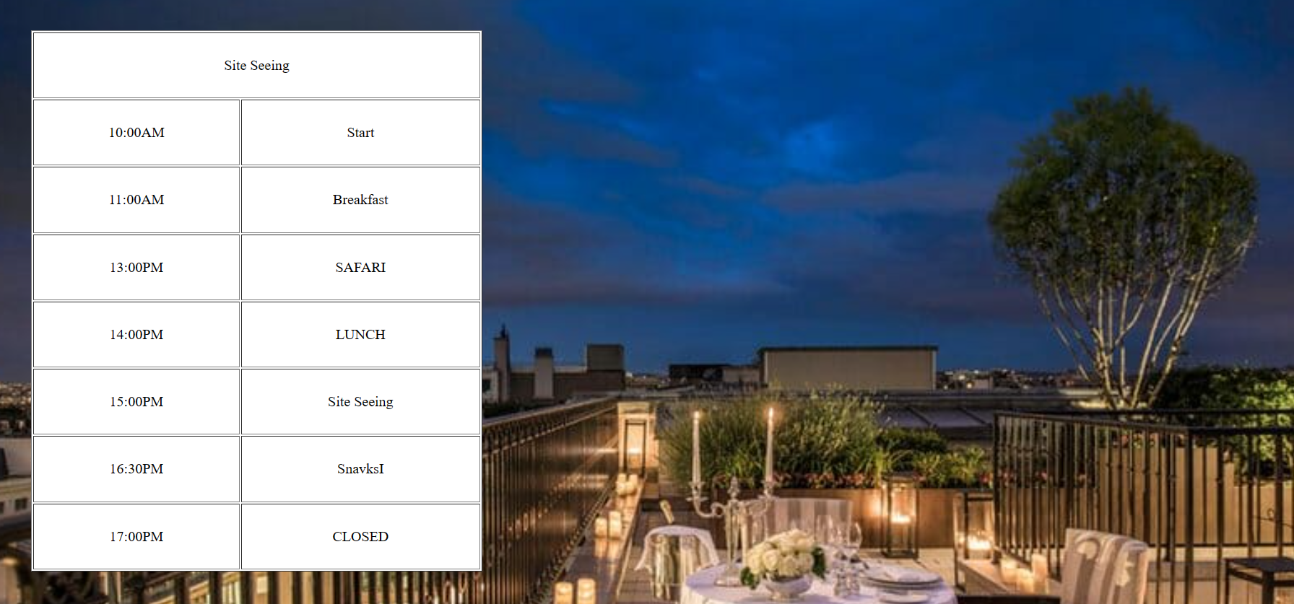

17.Location

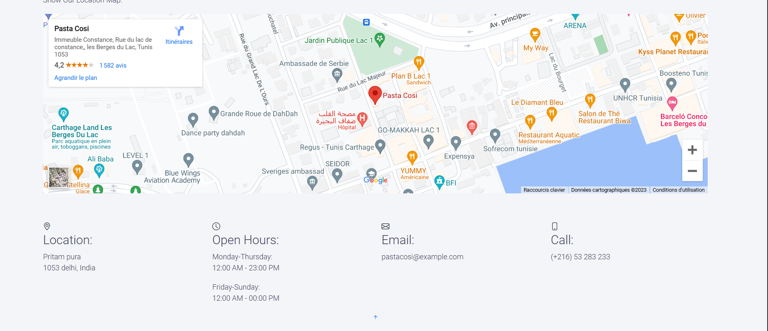

18.News & Events

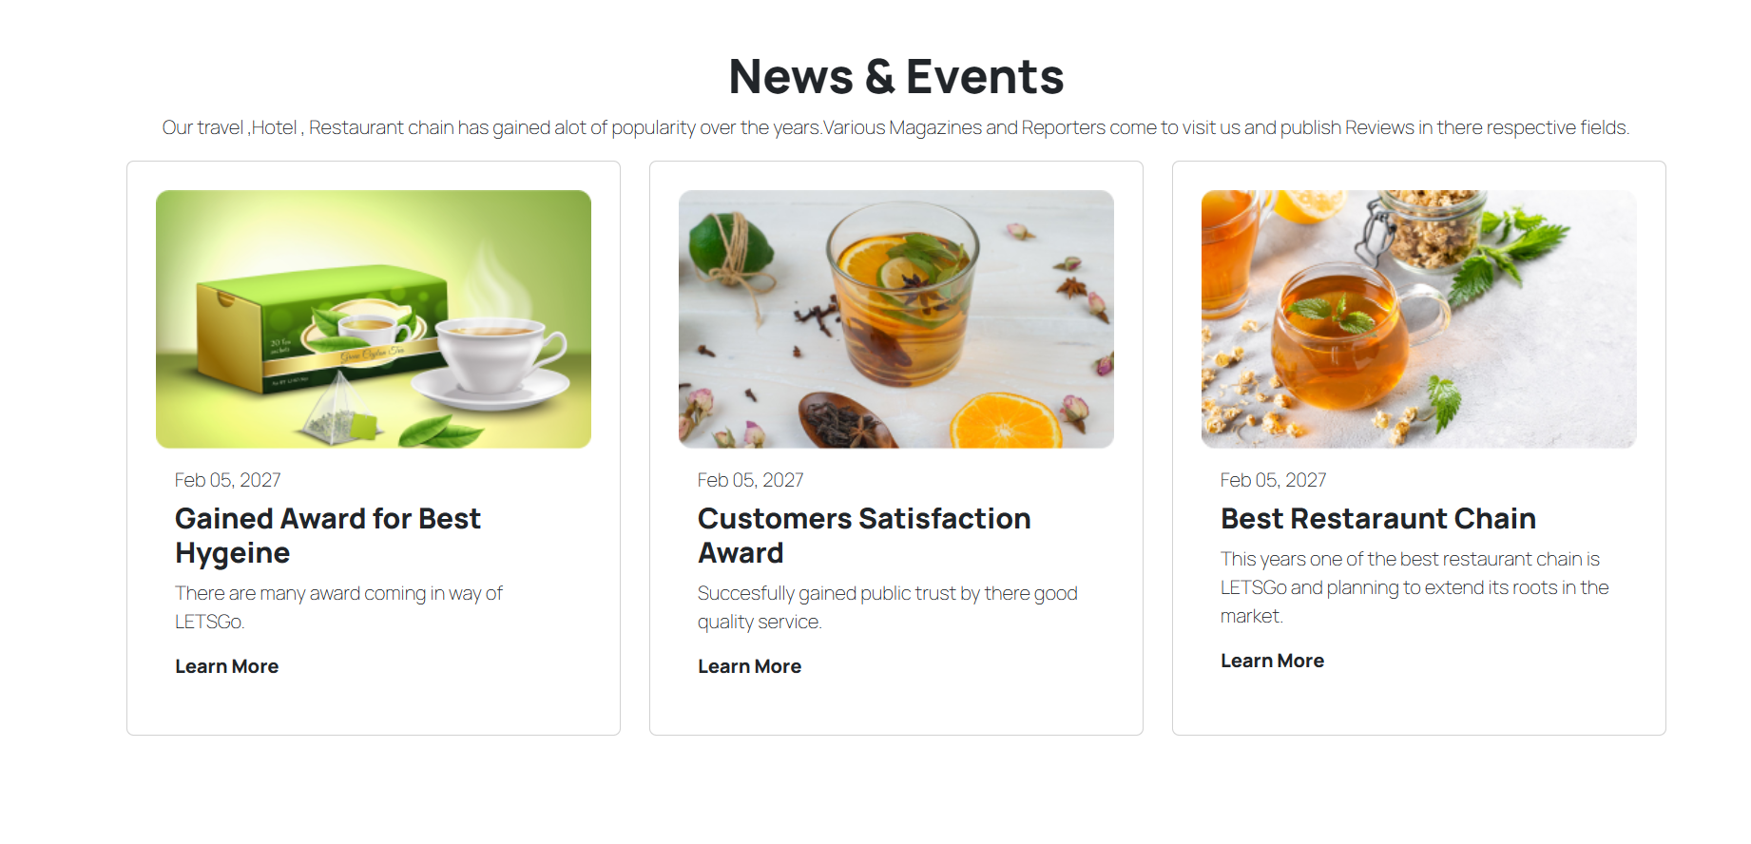

19.Faq’s

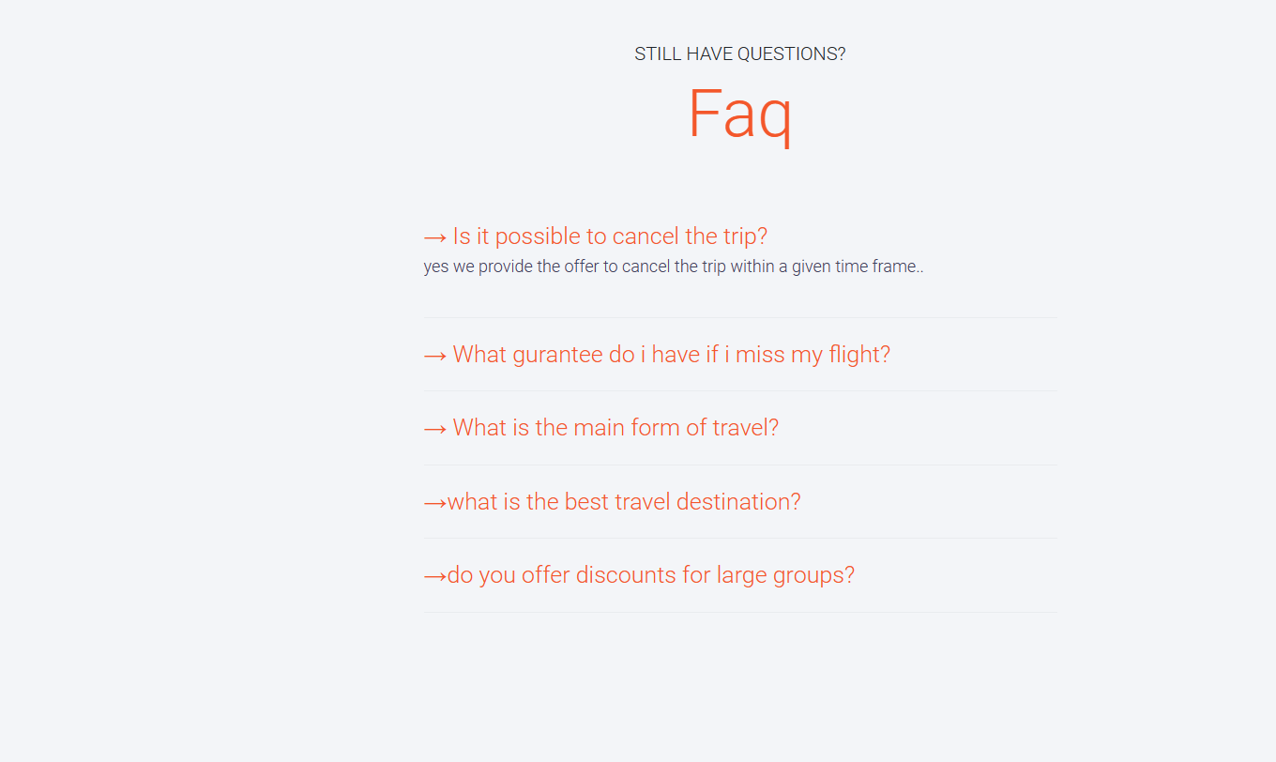

20.Contact us

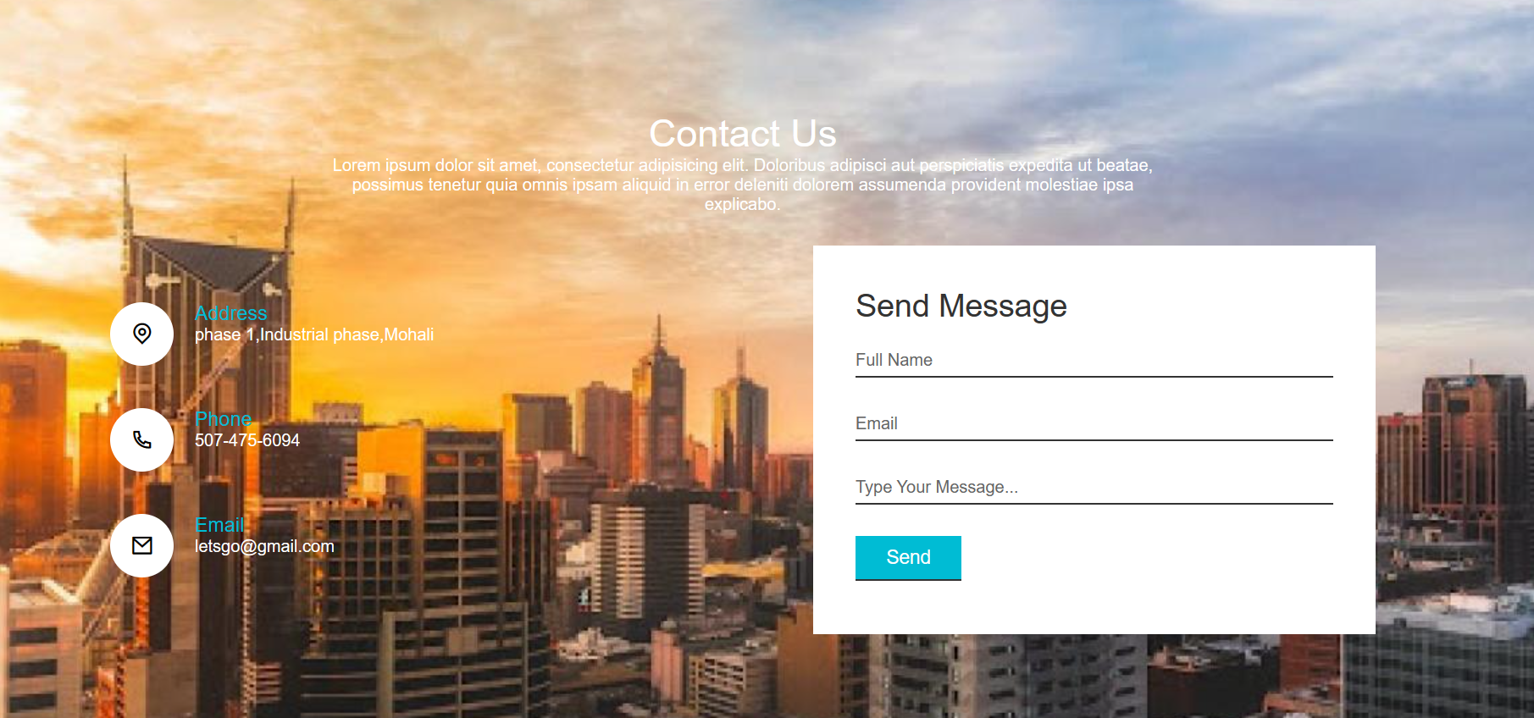

**ALL ABOUT LETSGo**

* LETSGo is basically a website which includes pages realted to travel,food,hotel stays,Site seeing etc.Its a complete travel guide for your ultimate goal trip to anywhere.
* One can easily go through all the pages and pre-plan his/her trip.
* This website is easy , efficient and smooth to use.
* Contrast of various colors is used to make the website look more appealing.
* It has various themes and options covered within it.
* It is made with the help of HTML,CSS,Java & Bootstrap.

**WHY LETSGo**

* I chose my theme of website as travel because I wanted to cover all the elements of travelling under one roof.
* One can simply book everything from his flight tickets to site seeing avail option via this website.
* Also it is made attractive via using CSS ,JAVASCRIPT AND BOOTSTRAP.
* Travel Websites have a lot of content to be covered.
* Pages like beaches and mountains make it more attractive.

**Number of pages**

* It has 20 pages.
* The main page is the Homepage consisting all parts of travelling in one.
* Next we have the Beach,tours,Hotels,Guesthouses,travel,Food,places pages.
* Then we have login,SignUp,SignIn,Payment,ContactUs pages.
* Also we have Package ,Review , Site Seeing ,Location,News and Events,Faq’s page.

What have been done?

* We have used- HTML,CSS,JAVASCRIPT & BOOTSRAP TO BUILD THESE PAGES.
* This consist of 20 pages.
* Every page is different from other in many ways.
* We have devided all the divs into Header,Sections and Footer to make it easy to understand code.
* The website is Responsive.
* It’s a travel website and cover all the necessary pages needed.

**Challenges**

* Amount of Content was a big problem.Making 20 pages on different themes was task.
* But I managed to cover it via thinking about important things needed so I don’t add uneccessary information.
* A perfect blend of all four types HTML,CSS,JAVASCRIPT AND Bootstrap was also must.
* A proper color theme and linking so many pages together was also a bit confusing but enhanced my managing skills.

**MOTIVE**

* The main motive Behind building it was to cover all the important elements needed under one roof.
* This website cover all aspects and works smoothly as well as is responsive.
* Also website like this helps user in many ways to make there planning for holidays easier.
* Main goal was to have a good look at the end with various fun features.

**Future**

* The future of these webpages will give a theme to build new websites related to such theme. I tried to build something nice by collaborating my ideas and getting few from online resources.This can be used to book flights and travel by any user when in need.
* Everything Is kept very simple yet very modern approach is followed. I tried to keep a versatility alive among different pages. I almost covered all the parts Like java,hyml,css and bootstrap in a good amount to complete the projects demand.